Sprint 1 Report

Scrum Tools, by the Scrum Mates, 2/17/2024

# Actions to stop doing

The team should stop implementing the designs before they are approved by everyone, including the sponsors, so that we don’t spend time on something that was not approved and will have to be redone.

# Actions to start doing

The team should start being more proactive in finding work and communicating in the Discord so that we are never idling with no work. We should also start meeting more every week to discuss design as a team, and also to have working sessions so that we are more up to date and can collaborate more often. Additionally, we need to start reviewing the burnup chart and scrum board every time we meet to make sure that it is up to date and we have a better understanding of our progress. We could also be more active in watching for PR reviews and requests for changes.

# Actions to keep doing

# The team should keep making pull requests on GitHub because it has helped us avoid merge conflicts. Unit testing has also been useful to help us make sure old components are still running correctly and alerting us to anything that breaks.

# Work Completed/Not completed

Completed tasks and stories are crossed out

### Story 1

| **Priority** | **Story** | **Acceptance Criteria** | **SP** |
| --- | --- | --- | --- |
| 1 - Must | As a product owner, I want to create new release plans so I can add to previous plans and communicate my plan to the team. | Have a good form for inputting and editing a release plan  Be able to create a new release plan based on the current release plan  Changes can be saved.  Have automatically generated version numbers depending on if a release plan is created fresh, or if it is a revision of a previous release plan.  Team can see all versions (previous versions, signed versions, unsigned versions) of the release plan. | 5 |

| **Tasks** | **Ideal Hours** |
| --- | --- |
| 1. ~~Design a page to view release plans~~ | ~~2~~ |
| 1. Implement the design into the app | 3 |
| 1. ~~Implement the Project, Release Plan, Sprint Plan entities for TypeORM~~ | ~~4~~ |
| 1. Create new backend functions to make a copy of a release plan | 1 |
| 1. Create new backend functions to save release plans | 1 |
| 1. Opening a release plan loads it into the editor | 2 |
| 1. Create new backend functions to get previous release plans’ versions | 3 |

### Story 2

| **Priority** | **Story** | **Acceptance Criteria** | **SP** |
| --- | --- | --- | --- |
| 1 - Must | As any user, I want to create, update, reorder, and delete user stories from the product backlog so that I can list new requirements for user functionality and more manage their relative priorities.. | Be able to create new user stories  Be able to input the user type, required functionality, and reasoning into a new user story.  Be able to provide the priority of a user story as 1, 2, 3, 4.  Be able to provide a Fibonacci number for story point estimates.  Be able to reorder user stories in the backlog.  Be able to update and delete user stories. | 5 |

| **Tasks** | **Ideal Hours** |
| --- | --- |
| 1. Rename the User Stories section to Product Backlog | 1 |
| 1. Implement a new design for creating new user stories | 3 |
| 1. Implement reordering of stories in the backlog | 4 |
| 1. Create backend function to save a new user story to database | 2 |
| 1. Create backend function to update/delete a user story | 2 |
| 1. Create a backend function to change the order of the backlog | 2 |
| 1. Connect frontend changes with backend functions | 4 |

# Work Completion Rate

Average user stories/day and average ideal work hours/day figures computed across all sprints to date.

Total number of user of stories completed during the prior sprint: 0

Total number of estimated ideal work hours completed during the prior sprint: 6

Total number of days during the prior sprint: 7 days

User Stories/day = 0/7 = 0 stories/day

Average user stories/day = avg(0) = 0 stories/day

Ideal hours/day = 6/7 = .86 ideal hours/day

average ideal hours/day = avg(.86) = 0.86 ideal hours/day

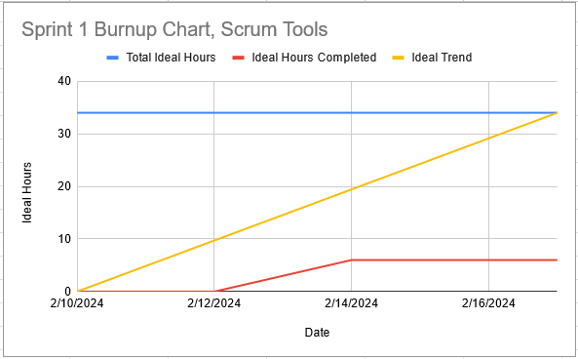

We got a late start to the sprint because the release plan and sprint plan were delayed by a day waiting for the sponsor meeting. Some team members were busy with midterms this sprint, so could not spend as much time working on the project. Also, some of the work that was completed was not up to the sponsor’s standards and will need to be redone. It was also difficult to get started on the design because the expectations and requirements felt unclear to us, but now they are clearer and we can start to work on them now. Next sprint, we can all spend more time on the project to get more done.

# Completed Scrum Board

